

Submitted By,
Name : Tasmia Hossain
ID : 20210204038
Section : A
Group : 1
Year/Semester : 4/1

Date of Submission : 09. 07. 2025
Submitted to ,
Saha Reno
Tahsina Muthaki
Course No : CSE 4142
Course Title : Data Warehousing and Mining Lab
Assignment 1
Department of Computer Science and Engineering
Ahsanullah University of Science and Technology

Introduction
This assignment focuses on understanding the importance of data preprocessing, class balancing, and model building in machine learning. The objective is to create a custom dataset with specified attributes and class distribution, apply data transformations, address class imbalance, and use a classification model (Naive Bayes) to predict outcomes on test data. This practical task provides insight into real-world data handling techniques essential in data mining.

Methodology
- Dataset Creation
A Dataset was created with 5 Attributes: 2 Numeric, 2 Nominal & 1 Class (3 Class Values).
@relation customer_decision

@attribute Age numeric
@attribute Income numeric
@attribute Gender {Male,Female}
@attribute City {Dhaka, Chittagong, Sylhet}
@attribute Decision {Buy, NotBuy, Consider}

- Instance Creation
20 instances were created with the following class distribution:
- 10 instances for class: Buy
- 6 instances for class: NotBuy
- 4 instances for class: Consider
@data
25, 26000.25, Male, Dhaka, Buy
30, 50000.75, Female, Dhaka, Buy
27, 30000, Female, Sylhet, Buy
35, 25000.50, Female, Chittagong, Buy
26, 15000, Male, Sylhet, Buy
40, 60000, Male, Sylhet, Buy
55, 45000.75, Female, Chittagong, Buy
45, 20000.75, Male, Dhaka, Buy
50, 36000, Female, Dhaka, Buy
32, 40000.00, Female, Chittagong, Buy
30, 25000, Female, Sylhet, NotBuy
20, 10000.50, Male, Dhaka, NotBuy
45, 60000.25, Male, Chittagong, NotBuy
35, 30000, Male, Chittagong, NotBuy
50, 36000.00, Male, Dhaka, NotBuy
27, 40000.75, Female, Chittagong, NotBuy
25, 30000.50, Male, Chittagong, Consider
40, 45000.75, Male, Dhaka, Consider
65, 50000, Male, Dhaka, Consider
50, 22000.25, Female, Sylhet, Consider

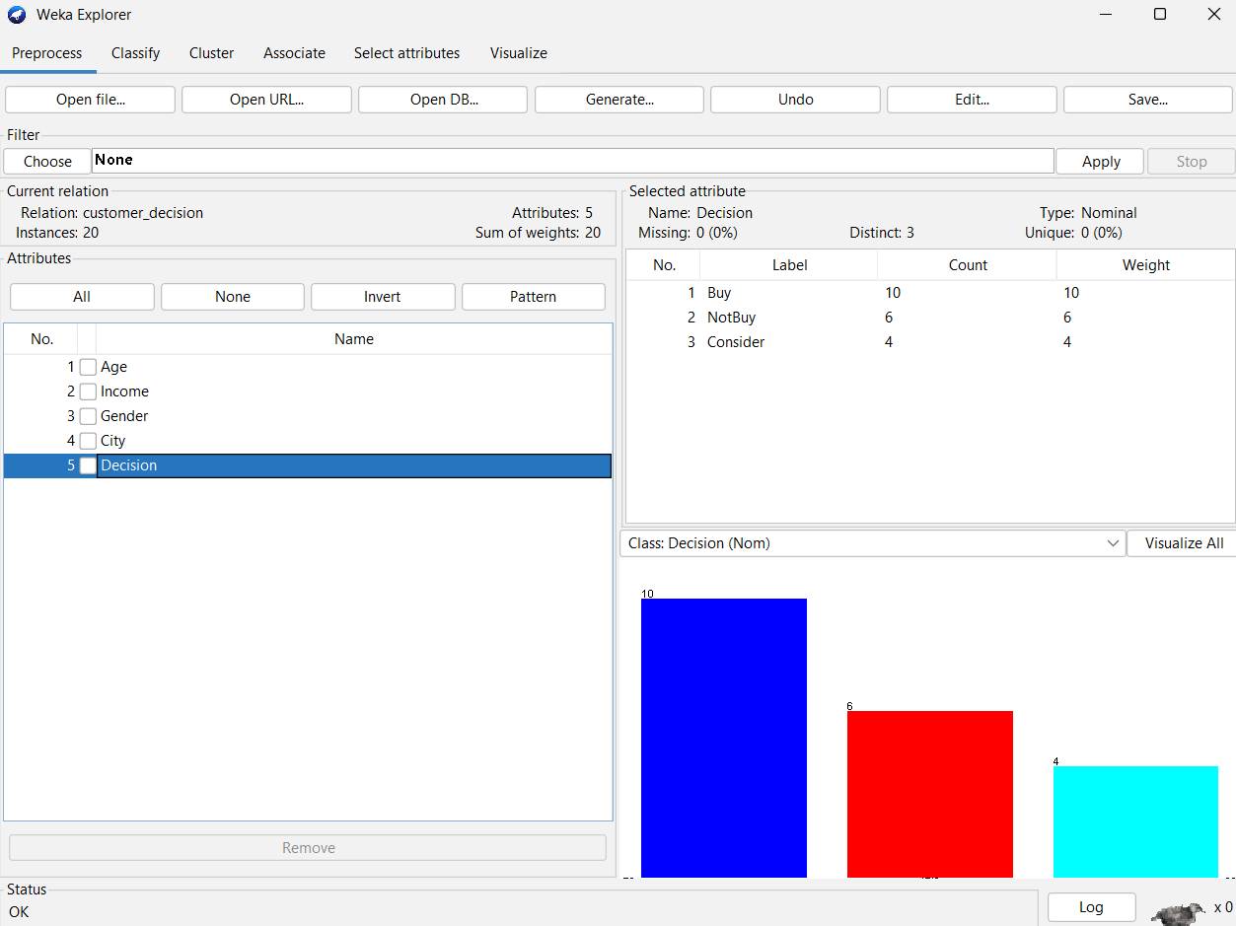

- Attribute Conversion
The Income attribute was originally a floating-point number. Using WEKA's MathExpression filter, the values were converted to integers using the floor function.

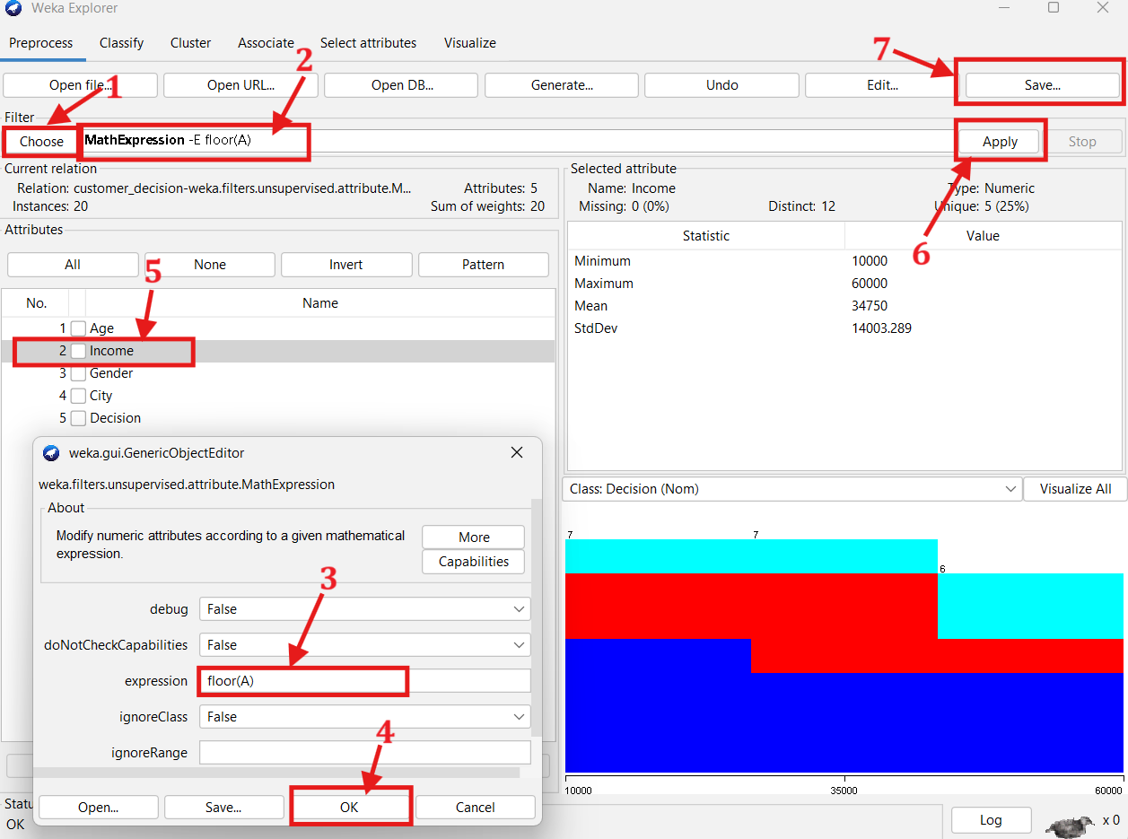
@relation customer_decision-weka.filters.unsupervised.attribute.MathExpression-Efloor(A)

@attribute Age numeric
@attribute Income numeric
@attribute Gender {Male,Female}
@attribute City {Dhaka,Chittagong,Sylhet}
@attribute Decision {Buy,NotBuy,Consider}

@data
25,26000,Male,Dhaka,Buy
30,50000,Female,Dhaka,Buy
27,30000,Female,Sylhet,Buy
35,25000,Female,Chittagong,Buy
26,15000,Male,Sylhet,Buy
40,60000,Male,Sylhet,Buy
55,45000,Female,Chittagong,Buy
45,20000,Male,Dhaka,Buy
50,36000,Female,Dhaka,Buy
32,40000,Female,Chittagong,Buy
30,25000,Female,Sylhet,NotBuy
20,10000,Male,Dhaka,NotBuy
45,60000,Male,Chittagong,NotBuy
35,30000,Male,Chittagong,NotBuy
50,36000,Male,Dhaka,NotBuy
27,40000,Female,Chittagong,NotBuy
25,30000,Male,Chittagong,Consider
40,45000,Male,Dhaka,Consider
65,50000,Male,Dhaka,Consider
50,22000,Female,Sylhet,Consider

- Class Balancing
To balance the dataset, SMOTE (Synthetic Minority Oversampling Technique) was applied.
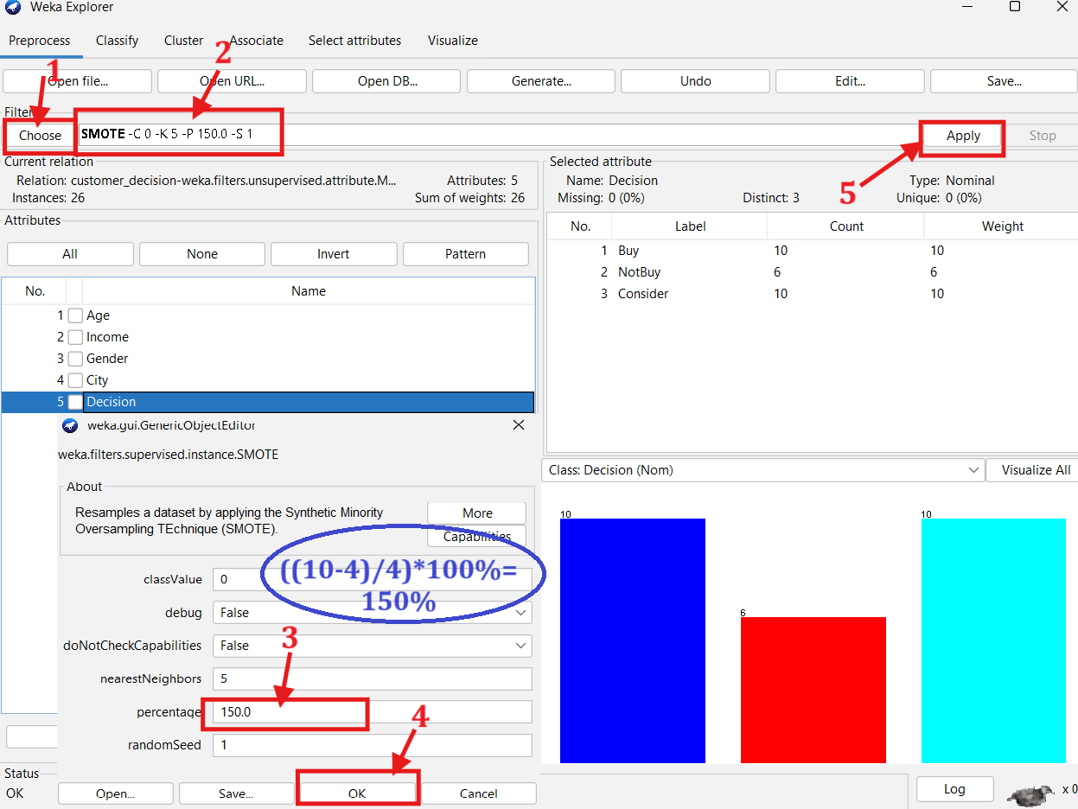

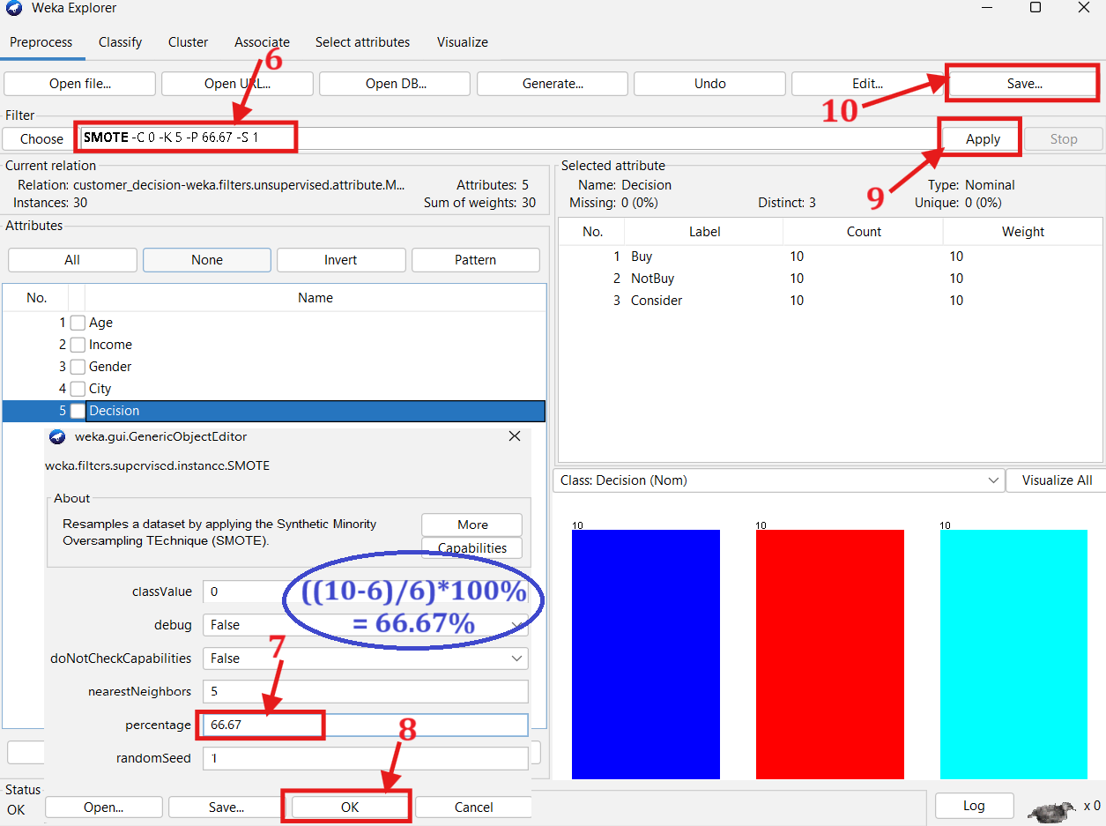
@relation customer_decision-weka.filters.unsupervised.attribute.MathExpression-Efloor(A)-weka.filters.supervised.instance.SMOTE-C0-K5-P150.0-S1-weka.filters.supervised.instance.SMOTE-C0-K5-P66.67-S1

@attribute Age numeric
@attribute Income numeric
@attribute Gender {Male,Female}
@attribute City {Dhaka,Chittagong,Sylhet}
@attribute Decision {Buy,NotBuy,Consider}

@data
25,26000,Male,Dhaka,Buy
30,50000,Female,Dhaka,Buy
27,30000,Female,Sylhet,Buy
35,25000,Female,Chittagong,Buy
26,15000,Male,Sylhet,Buy
40,60000,Male,Sylhet,Buy
55,45000,Female,Chittagong,Buy
45,20000,Male,Dhaka,Buy
50,36000,Female,Dhaka,Buy
32,40000,Female,Chittagong,Buy
30,25000,Female,Sylhet,NotBuy
20,10000,Male,Dhaka,NotBuy
45,60000,Male,Chittagong,NotBuy
35,30000,Male,Chittagong,NotBuy
50,36000,Male,Dhaka,NotBuy
27,40000,Female,Chittagong,NotBuy
25,30000,Male,Chittagong,Consider
40,45000,Male,Dhaka,Consider
65,50000,Male,Dhaka,Consider
50,22000,Female,Sylhet,Consider
30,27338,Male,Dhaka,Consider
35,32291,Male,Dhaka,Consider
63,49735,Male,Dhaka,Consider
52,45430,Male,Dhaka,Consider
54,36181,Male,Dhaka,Consider
36,26666,Male,Dhaka,Consider
34,58871,Male,Chittagong,NotBuy
23,17978,Male,Chittagong,NotBuy
21,13145,Male,Chittagong,NotBuy
36,35043,Male,Chittagong,NotBuy
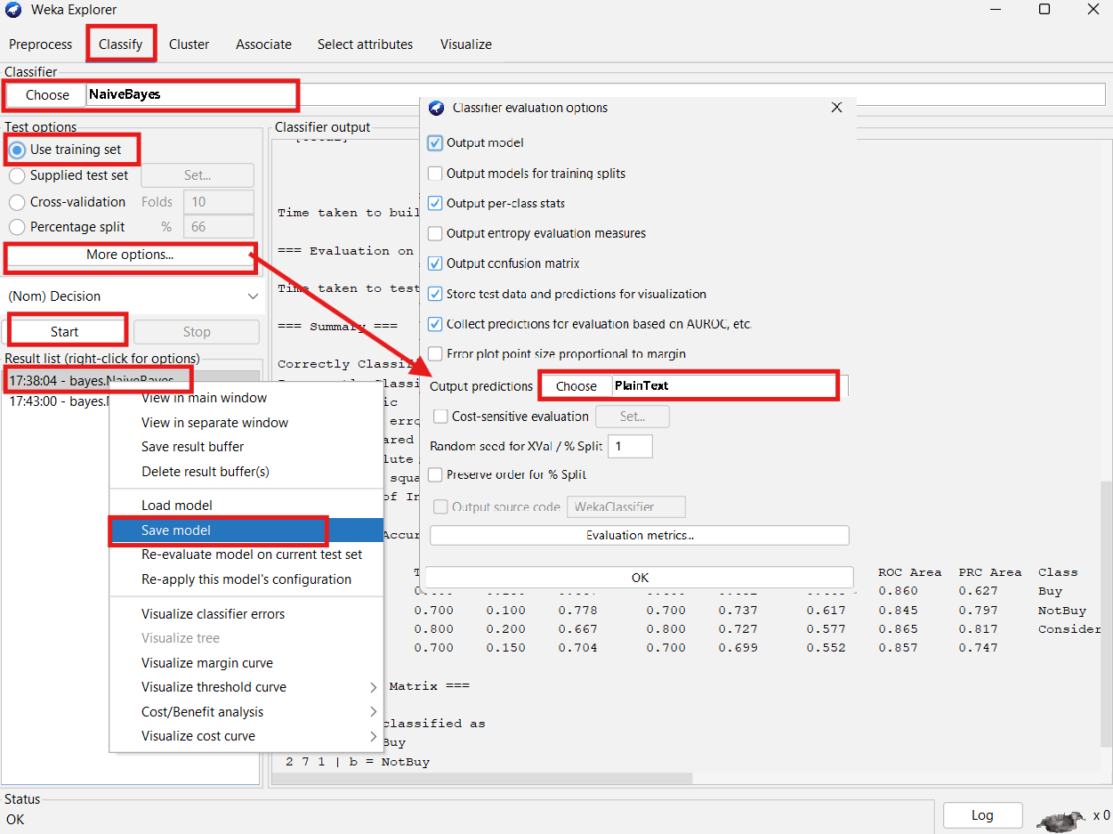
- Naïve Bayes Model
Test Dataset:
@relation customer_decision_test

@attribute Age numeric
@attribute Income numeric
@attribute Gender {Male,Female}
@attribute City {Dhaka, Chittagong, Sylhet}
@attribute Decision {Buy, NotBuy, Consider}

@data
33, 28000, Female, Dhaka, ?
47, 42000, Male, Chittagong, ?
29, 33000, Female, Sylhet, ?
55, 38000, Male, Dhaka, ?
42, 46000, Female, Chittagong, ?
31, 21000, Female, Sylhet, ?
40, 35000, Female, Sylhet, ?
45, 28000, Male, Chittagong, ?
60, 32000, Female, Sylhet, ?
53, 37000, Female, Dhaka, ?
52, 52000, Female, Chittagong, ?
30, 28000, Male, Sylhet, ?

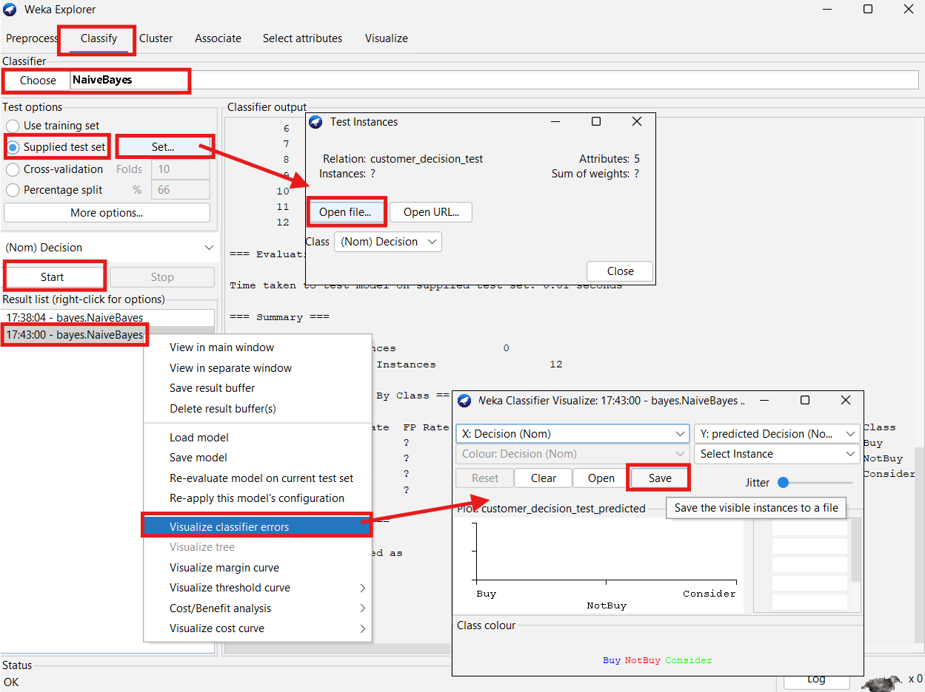
Modified Test Dataset with Predictions:
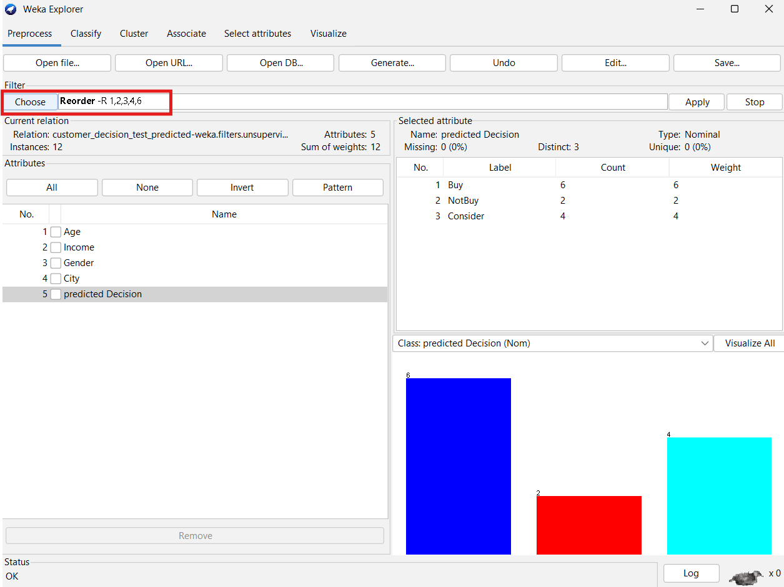
@relation 'customer_decision_test_predicted-weka.filters.unsupervised.attribute.Reorder-R1,2,3,4,6'

@attribute Age numeric
@attribute Income numeric
@attribute Gender {Male,Female}
@attribute City {Dhaka,Chittagong,Sylhet}
@attribute 'predicted Decision' {Buy,NotBuy,Consider}

@data
33,28000,Female,Dhaka,Buy
47,42000,Male,Chittagong,Consider
29,33000,Female,Sylhet,Buy
55,38000,Male,Dhaka,Consider
42,46000,Female,Chittagong,Buy
31,21000,Female,Sylhet,Buy
40,35000,Female,Sylhet,Buy
45,28000,Male,Chittagong,NotBuy
60,32000,Female,Sylhet,Consider
53,37000,Female,Dhaka,Consider
52,52000,Female,Chittagong,Buy
30,28000,Male,Sylhet,NotBuy

Result Analysis
The preprocessing step of converting float income values to integers ensured consistency in data representation. Balancing the dataset using SMOTE corrected the initial class imbalance (Buy: 10, NotBuy: 6, Consider: 4), generating 10 instances for each class.
After training the Naive Bayes model on the balanced data, predictions were made on a test set of 12 instances. The model produced varied class predictions, indicating successful learning and generalization.
- SMOTE balanced the dataset for fair training.
- Income attribute conversion reduced noise.
- Naive Bayes effectively predicted diverse class labels.
- The process demonstrated an end-to-end data mining workflow using WEKA

Conclusion
This assignment provided hands-on experience in data preprocessing, dataset balancing, and classification model implementation. Through constructing a dataset, transforming attributes, applying SMOTE, and using the Naive Bayes algorithm, I have deepened my understanding of foundational data mining practices. These skills are crucial for building accurate and fair predictive models in real-world applications.

